**Assignment 2**

|  |  |
| --- | --- |
| **Prerna.** | **1410110306** |
| **Vishal Gauba** | **1410110501** |
| **Pranjal Mathur** | **1410110296** |
| **Saketh Vallakatla** | **1410110352** |

**Calculate the data rates for a few settings and plot the received file size as a function of data rate. Report the attributes of data (type, bit rate(s) and encoding(s)) along-with your settings, that is, payload size and sleep delays, and the resulting data rate needed for playing the data smoothly in real time.**

**File Type:** .wav

**Bit Rate:** 545 Kbps (0.06 MBps)

**Encoding: Video:** AVC **; Audio:** AAC

|  |  |  |  |  |  |
| --- | --- | --- | --- | --- | --- |
| Buffer Size (in Bytes) | Time Delay(in ns) | Data Rate (MBps) | Send Size(Bytes) | Received Size(Bytes) | Received Size(MBs) |
| 40480 | 600000000 | 0.06 (539Kbps) | 12062720 | 12062720 | 12.06272 |
| 40480 | 500000000 | 0.08 (647Kbps) | 12062720 | 12062720 | 12.06272 |
| 40480 | 20000000 | 2.024 | 12062720 | 12062720 | 12.06272 |
| 40480 | 10000000 | 4.048 | 12062720 | 12062720 | 12.06272 |
| 40480 | 5000000 | 8.096 | 12062720 | 12062720 | 12.06272 |
| 40480 | 2000000 | 20.24 | 12062720 | 12062720 | 12.06272 |
| 40480 | 1000000 | 40.48 | 12062720 | 12062720 | 12.06272 |
| 40480 | 500000 | 80.96 | 12062720 | 12062720 | 12.06272 |
| 40480 | 300000 | 134.9333333 | 12062720 | 12022240 | 12.02224 |
| 40480 | 200000 | 202.4 | 12062720 | 11900800 | 11.9008 |
| 40480 | 50000 | 809.6 | 12062720 | 11010240 | 11.01024 |
| 40480 | 100 | 404800 | 12062720 | 9593440 | 9.59344 |

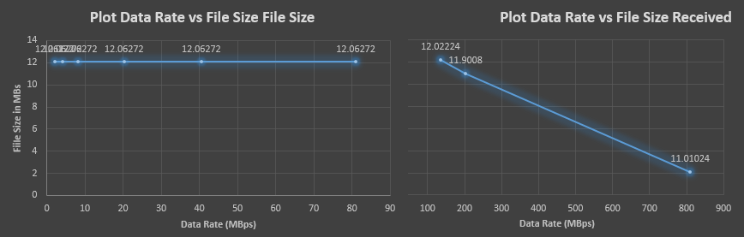

**Based on observation, data rate to play the file smoothly >= 0.07 MBps (545 Kbps)**